**IFT 166 Introduction to Internet Networking**

**Lab 30**

**One More Fix**

**+**

**Extra Credit**

**After you complete each step, put a ‘√’ or ‘x’ in the completed box   
or**

**Provide answers to the open questions**

**Objective**

Find out why a laptop can not ping a PC.

1. In packet tracer, open the file “One more fix” (located in the modules sections below this lab).   
     
   You should see the following topology.

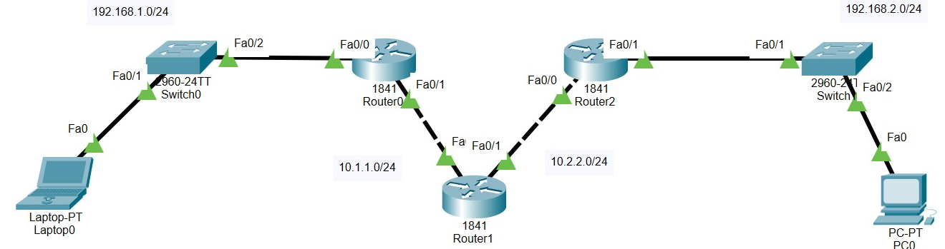



1. The laptop cannot ping the PC and vice versa. Why?

_________________________________________________________________________

_________________________________________________________________________

**Extra Credit (100 points)**

Implement a solution to get the laptop to communicate with the PC.

What is your possible solution?

_________________________________________________________________________

_________________________________________________________________________

_________________________________________________________________________

**Attach a screenshot of a successful ping between the laptop and then PC.**